# Executive Summary

# Background and Motivations

This position paper is an output from efforts conducted by the AIAA Digital Engineering Integration Committee Subcommittee on Computational Design and Analysis for Digital Engineering (DEIC-CoDADE). Digital engineering, as defined by DoD Instruction 5000.97, “is a means of using and integrating digital models and the underlying data to support the development, test and evaluation, and sustainment of a system” [1]. The DEIC is an AIAA integration committee that

The origin of DEIC-CoDADE stems from DEIC-CoDADE co-chair Rick Arthur’s identification of topics and subject areas that the other DEIC subcommittees and technical initiatives were not covering. These topics included discussions of interoperability with computational methods, high performance computing, and enabling technologies and methodologies of these. This further evolved into DEIC-CoDADE representing both the digital architects of the DEIC and those who are stakeholders to DEIC outputs – teams conducting computational design and analysis and those who are stakeholders to computational design and analysis efforts (e.g., program management, end-product users, direct customers, tool vendors, regulatory bodies).

## Purpose of DEIC-CoDADE

The main roles that DEIC-CoDADE fit with respect to the DEIC and those who are stakeholders to DEIC outputs are:

* Acting as an information loop between digital architects and those who utilize digital engineering.
* Monitoring and tracking the kinds of question and areas of study that those who would utilize digital engineering are investigating.
* Generating, collating, and reporting on engineering guidelines and best practices for addressing open questions and areas of study that those who utilize digital engineering are investigating.
* Providing digital architects recommendations on high-utility problems and gaps those who utilize digital engineering are experiencing.

The specificity of focusing on CoDADE stems from the impacts that computational design and analysis (CoDA) have on the aerospace industry overall. CoDA impacts how aerospace-related design is conducted (***Figure 1***), but it also introduces other requirements for enabling computational design and analysis (***Figure 1*)**. One of CoDADE’s objectives is to demonstrate how digital engineering can be used to support the positive impacts of CoDA and provide recommendations to mitigate the drawbacks of using CoDA.

***Figure 1:***

***e.g., supporting various aircraft certifications, optimization of a multi-scale complex design space, the mitigation of the severity of consequences of hazardous system behavior, optimizing SWaP***

***e.g., managing intellectual property and secure information, data quality and integrity requirements, hardware and software infrastructure, willingness to buy in, ensuring confidence in models, uncertainty quantification, trust***

This position paper is intended to contribute to CoDADE being a “bridge” between DEIC and those would benefit from the outputs of the DEIC (i.e., those who would utilize digital engineering to conduct CoDA). As a result, this position paper is intended to:

* Provide a set of guidelines, standards, and best practices for people to utilize to realize the full benefits of digital engineering.
* Identify current gaps in knowledge or practice that can become avenues of further research and development.

Considering the vast field that is CoDA for aerospace design, DEIC-CoDADE sought input and feedback from those would utilize digital engineering to conduct CoDA for aerospace problems. This effort is discussed in Section 2.2.

## Scoping This Position Paper

Based on the charter of the DEIC-CoDADE subcommittee, an approach for scoping this position paper is to review existing published gap analyses and vision statements made by different entities within the aerospace community. Another approach for scoping the position paper is to directly survey those who utilize digital engineering for computational design and analysis. For scoping the topics of discussion in this position paper, the authors employed both approaches.

### Existing Visions, Positions, and Publications

DEIC-CoDADE utilizes the following definitions for various aspects of digital engineering, including:

* Digital engineering - A means of using and integrating digital models and the underlying data to support the development, test and evaluation, and sustainment of a system [1].
* Digital twin - A set of virtual information constructs that mimics the structure, context and behavior of an individual / unique physical asset, or a group of physical assets, is dynamically updated with data from its physical twin throughout its life cycle and informs decisions that realize value [2, 3].
* Digital thread: A collection of linked authoritative digital information pertaining to a process, product, or system, whose consistency is actively managed throughout the life cycle. This enables accessibility, traceability, currency, applicability, and credibility of information, thus facilitating the capture, communication, and use and reuse of knowledge to efficiently inform decisions that realize value [4].
* Digital ecosystem: (***INCLUDE DEFINITION FROM THEIR POSITION PAPER)***

With these definitions in mind, DEIC-CoDADE next scoped the topics that would be covered within CoDA. One source of this scoping was NASA’s 2040 Vision: A Roadmap for Integrated, Multiscale Modeling and Simulation of Materials and Systems. The 2040 Vision’s desired realized state is “a cyber-physical-social ecosystem that impacts the supply chain to accelerate model-based concurrent design, development, and deployment of materials and systems throughout the product life cycle for affordable, producible aerospace applications” [5]. The 2040 Vision identified 9 key development areas, and within those, 117 technical gaps, 180 recommended actions to close those gaps, and 9 interdisciplinary engineering challenge problems. The 9 key development areas and the critical gaps within those areas are in Table 1.

Table 1: Key elements for realizing the NASA 2040 Vision State, descriptions of each key element and the critical gaps for each key element [5, 6].

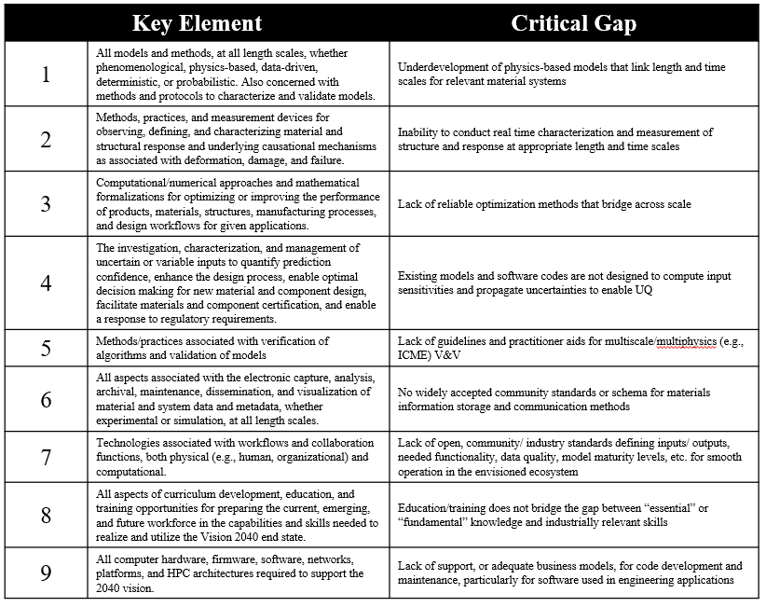

These key elements were further distilled into four high-level disciplines to study, which are CoDA framework analysis development, data management, hardware/software infrastructure co-design, and the role of organization strategy and culture. Further discussion on the topics within each of these disciplines that will be within this position paper are in Section 2.4.

Although the position paper is now able to target four high-level disciplines, additional refinement of scope was required. Further refinement came from the results of the AI Readiness Survey that was distributed by NAFEMS in 2024. There were 802 respondents to the survey, and the respondents were asked questions related to how their organization uses AI/ML for engineering simulation, level of AI maturity within the organization, and barriers to AI adoption, among other questions. Ultimately, the survey results demonstrated that most of the respondents’ organizations do not have a mature AI capability, and the vast majority is not utilizing ML/AI in an ethical and responsible manner. Based on these findings, the DEIC-CoDADE further concentrated their topics of interest to address concerns of interoperability and appropriate use of digital engineering with methods and technologies within each high-level discipline. The definitions of appropriate use and interoperability are as follows:

* Appropriate use - A subset of considerations within responsible use of methods, appropriate use considers the following: 1) Are the models, data, and decision-making process validated for the desired application? (2) Are the models, data, and decision-making process sufficiently mature for quantification of uncertainty and establishing trust?
* Interoperability - The ability of systems, units, or forces to provide data, information, materiel, and services to, and accept the same from, other systems, units, or forces, and to use the data, information, materiel, and services exchanged to enable them to effectively operate together. In the context of non-deterministic methods (including, but not limited to, AI), the goal is to emphasize how interoperability of these methods with other digital infrastructure can be supported in an appropriate manner [7].

Considering the above definitions for digital engineering constructs, the high-level subject areas that will compose chapters of this position paper, and critical characteristics for supporting CoDADE, Section **Error! Reference source not found.** will review the survey that DEIC-CoDADE circulated and the results from it.

### AIAA DEIC-CoDADE Survey

DEIC-CoDADE generated a survey that was fielded between October and November 2024. The survey overall was intended to elicit inputs from those who utilize digital engineering on whether they believe that the DEIC-CoDADE’s position on digital engineering would apply to a variety of different technical topics. Further discussion on the survey, survey topics and questions, and detailed discussion of the result will be in (***SURVEY WHITE PAPER CITE HERE***).

Ultimately, the survey was able to yield a statistically significant number of responses, and these responses demonstrated shared challenges among them. One of these shared challenges is that respondents identified the use of AI/ML and tradition modeling/simulation methods in a hybrid, integrated fashion and AI/ML applied to automation and data analysis as areas of desired study. Respondents believe that these AI/ML topics are currently gaining the least benefit from digital engineering and that these topics need additional guidelines for maximizing interoperability and appropriate use.

Respondents also noted the need and importance and standardization and suggestions of guidelines and best practices across all subject areas discussed in the survey to better support the realization of digital engineering. With respect to data management, respondents emphasized the need for additional standardization and guidelines in managing simulation verification and validation data, unstructured text data, and metadata. Another respondent observed the need for standardization of methodologies for incorporating process-driven tools that are needed across the product life cycle in a digital environment. Another respondent also highlighted that guidelines between interoperability and appropriate use of digital engineering and open stands of model and data management would support adoption of these open standards and fully realize the promise of digital engineering.

However, according to respondents, the greatest challenges for advancing and fully realize digital engineering include training developers, educating leadership, and aligning needs/goals across their respective organizations. One respondent noted that “senior staff members view hardware in the loop testbeds as more reliable than digital twins. Digital twin developers are younger and have less experience with HW and SW issues that they should model.” Consequently, additional guidelines on how to demonstrate utility, validation, and trust in digital twin development would support educating leadership in technical roles.

Another respondent noted that it “(…) appears that systems architecture is what folks are focused on as opposed to connecting the digital thread to everyday tasking” and that “Digital engineering workflows and culture shifts in corporations need to happen at the working level in order to meet the demand customers have for aerospace products.” This implies that those would utilize digital engineering need examples on how to use digital engineering constructs to solve problems they regularly face, as opposed to just emphasis on digital engineering architectures.

## AI is a Metaphor

Before considering how to use AI in an interoperable and appropriate manner, one must first define what AI is. ***INSERT REFERENCE TO TABLE HERE*** A common theme across all these definitions is that AI is a mimicry of human cognitive function. However, considering that human beings have an evolving, but incomplete, understanding of their own cognition, how can individuals utilizing AI in their aerospace applications ensure they are using it in an interoperable and appropriate manner?

|  |  |
| --- | --- |
| **Definition of Artificial Intelligence (AI)** | **Source of Definition** |
| The ability of machines to perform tasks that normally require human intelligence. For example: recognizing patterns, learning from experience, drawing conclusions, making predictions, and taking action – whether digitally of as the smart software behind autonomous physical systems. [8, 9] | Summary of the 2018 DoD AI Strategy |
| The term artificial intelligence includes the following: (1) Any artificial system that performs tasks under varying and unpredictable circumstances without significant human oversight, or that can learn from experience and improve performance when exposed to data sets. (2) An artificial system developed in computer software, physical hardware, or other context that solves tasks requiring human-like perception, cognition, planning, learning, communication, or physical action. (3) An artificial system designed to think or act like a human, including cognitive architectures and neural networks. (4) A set of techniques, including machine learning, that is designed to approximate a cognitive task. (5) An artificial system designed to act rationally, including an intelligent software agent or embodied robot that achieves goals using perception, planning, reasoning, learning, communicating, decision making, and acting. [8, 10] | John S. McCain National Defense Authorization Act for FY2019 9 – Sub B/Sect 238g |
| A machine-based system that can, for a given set of human-defined objectives, make predictions, recommendations or decisions influencing real or virtual environments. Artificial intelligence systems use machine and human-based inputs to—(A) perceive real and virtual environments; (B) abstract such perceptions into models through analysis in an automated manner; and (C) use model inference to formulate options for information or action. [8, 11] | National AI Initiative Act of 2020 (FY2021 NDAA) |
| Any artificial system that performs tasks under varying and unpredictable circumstances without significant human oversight, or that can learn from experience and improve performance when exposed to data sets. [8, 12] | 10 U.S. Code § 2358 |
| Software and/or hardware that can learn to solve complex problems, make predictions, or undertake tasks that require human-like sensing (such as vision, speech, and touch), perception, cognition, planning, learning, communication, or physical action. [8] ***(NEED SOURCE HERE)*** | National Institute for Standards and Technology |
| The science and engineering of making intelligent machines, especially intelligent computer programs. It is related to the similar task of using computers to understand human intelligence, but AI does not have to confine itself to methods that are biologically observable. [13] | Professor Emeritus John McCarthy, Who Originally Coined the Term “Artificial Intelligence” |

While there is no singular answer to this question, Section 2.3 will provide a DEIC-CoDADE position on this question. AI is really a metaphor for human cognition in the way that it is based on our understanding of human cognition, as opposed to cognition itself. Neural networks, for example at a high level, are ontological representations of how different models relate to each other via inputs and outputs. The nodes in neural networks are akin to individual points of cognition (i.e., an individual task) and the nodes are laid out in a topological manner to demonstrate how they relate to each other.

With this approach for describing artificial intelligence, one can simplify how to establish confidence via validation that AI is being used in an interoperable and appropriate manner. Validation of the application of the AI model relies on a clear understanding of the intent and purpose of applying the AI. Intent and purpose of application drives the requirements of applying the AI in an appropriate and interoperable manner and it also drives how to demonstrate that those requirements are met. In the context of the neural network example from before, validating the application of the AI model results in validating the topological component: how individual nodes of the artificial intelligence relate to each other. The other component to validation is model validation, which is covered in more detail in Section 3.

## High-Level Questions to Address Using Digital Engineering

AI/ML + Traditional Mod/Sim & AI/ML applied to data analysis open questions

* Machine Learning, Decision Making, and Trust
  + Role of AI in Decision Making (e.g., AI-derived decisions vs. human expectations)
  + Debate on Model Correctness (George Box vs. “All models are correct” vs. “All models are incomplete”)
  + Transparency and trust in AI modeling
  + How to describe the “region of competence” for models
  + How to identify appropriate parameters and features for training models
  + How to navigate intellectual debt (“unexplainability”) of data and models
  + How to conduct model validation using uncertainty quantification (including distinction between epistemic and aleatoric uncertainties)
  + How to use unsupervised machine learning appropriately
* Complexity of Multi-Physics and Nonlinearity
  + Decomposition of complex systems (e.g., engine modeling)
  + Surrogate modeling is your best friend (how it facilitates multiscale and high-fidelity modeling)
* Contextualizing Different Computational Methods and Model Development Standardization
  + Physics-based methods
  + Human-created models
  + Data-derived models

Data Management

* How to manage simulation and verification data
* How to manage unstructured text data
* How to manage metadata
* Consistency management of data

Hardware/Software Infrastructure Co-Design

* Artificial constraints of traditional computational approaches
* Theoretical idea: infinite computational resources vs. practical applications
* How to incorporate process-driven tools across the life cycle
* How digital engineering can impact different kinds of scaling
* How to adopt open standards for hardware/software co-design
* How to best incorporate high performance computing

Role of Organization Strategy and Culture

* How to train developers and digital engineering novices
* How to educate leadership and prove value
* How to ensure goals are aligned across the organization
* Generate a closed loop between digital engineering and the design, test, and evaluation community

# Computational Design Analysis Framework Development

# Data Management

# Hardware and Software Infrastructure Co-Design

# Role of Organization Strategy and Culture